

**UNIVERSITY OF PETROLEUM AND ENERGY STUDIES**

**School of Computer** **Science**

**2020-21**

**GRAPHICS AND ANIMATION TOOLS LAB**

**Faculty: Dr. DURGANSH SHARMA**

**Assistant Professor**

**Department of Cybernetics.**

**School of Computer Science, UPES**

**Submitted By:**

**Name- Garima Dhall**

**Roll no-R100217025**

**Batch-B1**

**Semester- 7**

**Course-B.tech. CSE-OSOS**

**Sap Id- 500062498**

**EXPERIMENT NO 2**

**Aim** :- Design of Logo using GIMP

**Objective** :- To Design a logo of your own choice using features of GIMP.

**STEPS TO MAKE LOGO :-**

1. Open GIMP workspace on your device and take the image of your choice here I want to construct a logo for the toy shop so I have picked up a image from my web browser .

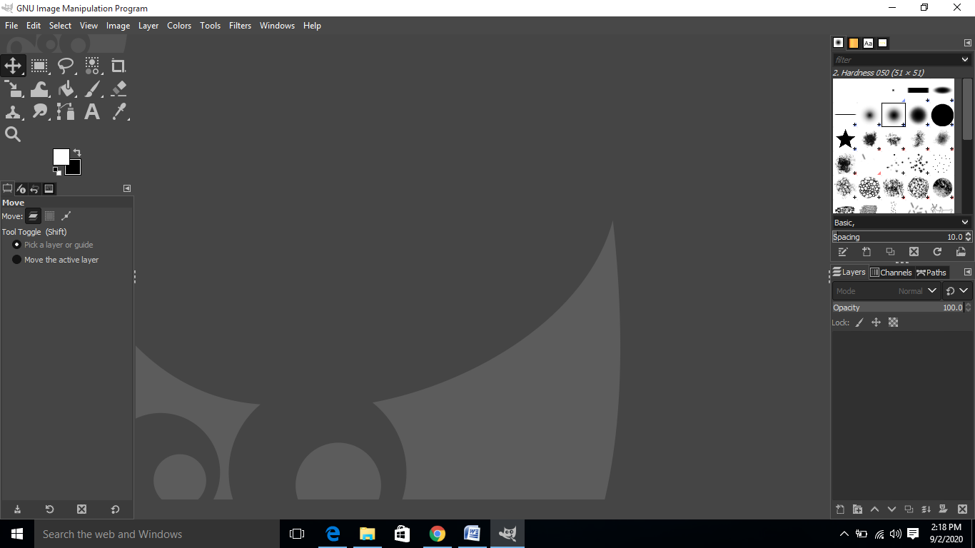

1. Then click on the option FILE and then click on OPEN and choose the location where you have saved your image and the image gets open in GIMP

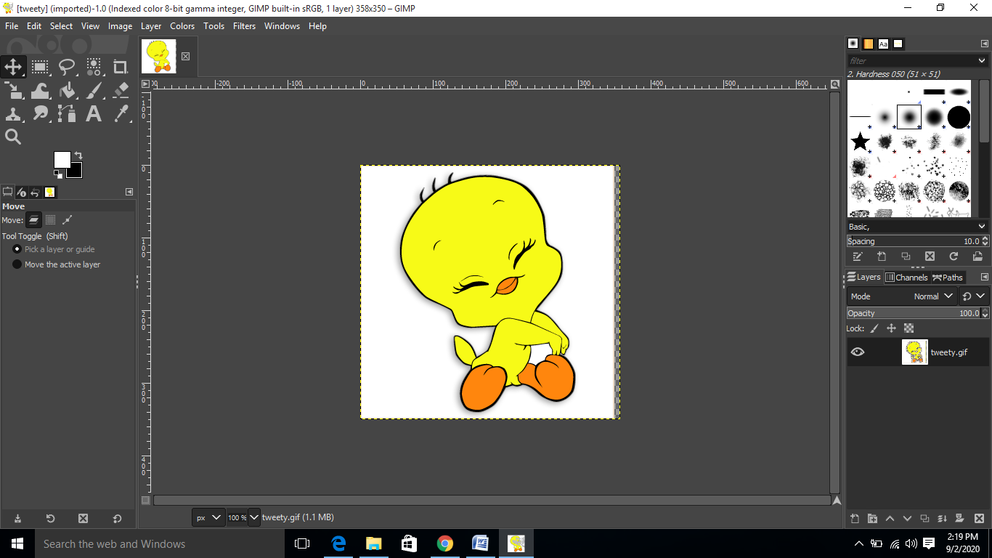

1. After the image gets open then select the free selection tool and select only that part of image which you want and remove the background

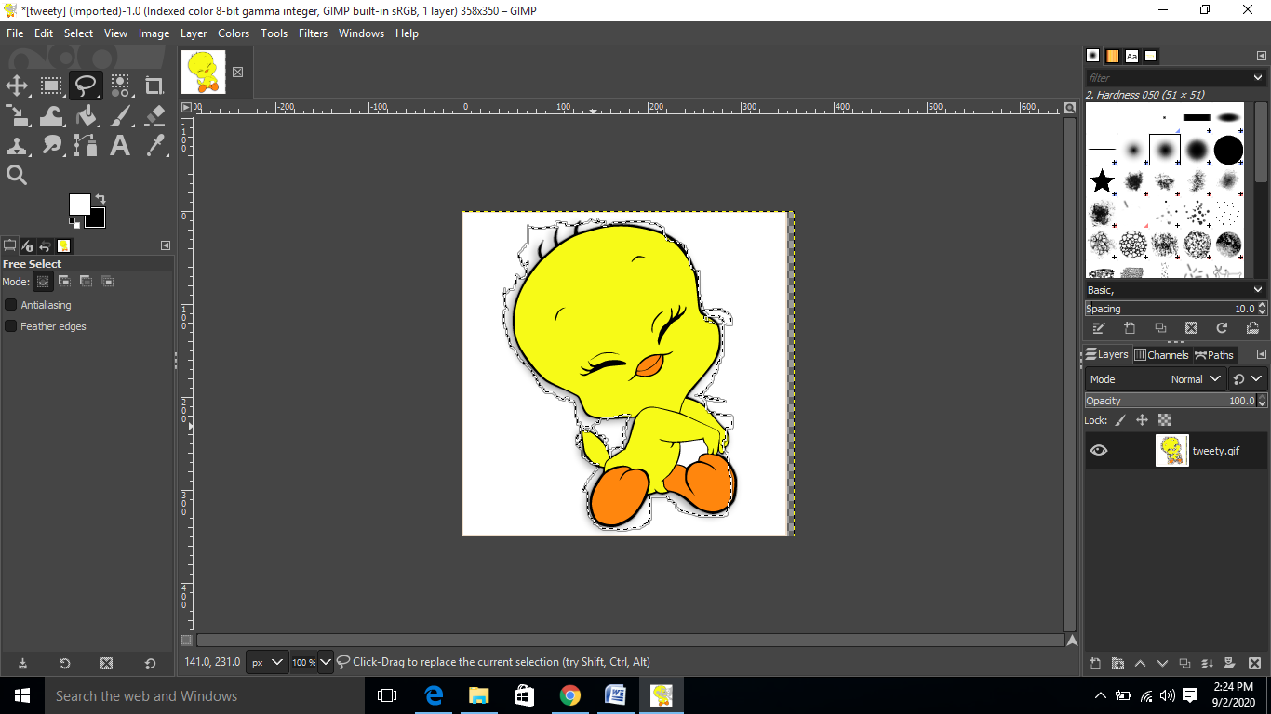

1. After selecting the region cut the image and paste it on the new template and write the text of your own choice in my case I have written the text looney tunes toy shop

